**Metro Map MakerTM**

**Software Design Description**

**Author: Manpreet Singh, October, 2017**

**Version 1.0**

**Abstract:This document describes the software design for Metro Map Maker, an application to build and modify graphical representations of city subway systems with named lines and named stops and intersecting lines and landmarks.**

**1 Introduction**

This is the Software Design Description (SDD) for the Metro Map MakerTM application. Note that this document format is based on the IEEE Standard 1016-2009 recommendation for software design.

**1.1 Purpose**

This document is to serve as the blueprint for the construction of the Metro Map Maker application. This design will use UML class diagrams to provide complete detail regarding all packages, classes, instance variables, class variables, and method signatures needed to build the application. In addition, UML Sequence diagrams will be used to specify object interactions post-initialization of the application, meaning in response to user interactions or timed events.

**1.2 Scope**

For this project the goal is for users to easily make and edit subway maps. There will be an emphasis on ease of use. Note that there will be a common export format that will be provided for exported subway system data such that all maps can be used by a uniform application.

**1.3 Definitions, acronyms, and abbreviations**

**Framework** – In an object-oriented language, a collection of classes and interfaces that collectively provide a service for building applications or additional frameworks all with a common need.

**JSON – J**ava**S**cript **O**bject **N**otation. This is a file format to which everything will be saved when working and saving inside this application.

**jTPS –** A simple framework that takes care of undoing and redoing various actions in the application.

**DOM –** Document Object Model; this is a basic skeleton of a page that is created by a browser upon successful loading of a web page.

**GUI** – Graphical User Interface, visual controls like buttons inside a window in a software application that collectively allow the user to operate the program.

**IEEE** – Institute of Electrical and Electronics Engineers, the “world’s largest professional association for the advancement of technology”.

**Java –** The high-level programming language that will be used in this program. Java uses a virtual machine layer between an application and the hardware on which the application runs to ensure that it will run on any platform.

**Stylesheet** – a static text file employed by HTML pages that can control the colors, fonts, layout and other style components in a Web page.

**UML** – Unified Modeling Language, a standard set of document formats for designing software graphically

**Use Case Descriptions** – A formal format for specifying how a user will interact with a system.

**1.4 References**

**IEEE Std 830TM-1998 (R2009)** – IEEE Standard for Information Technology – Systems Design Software Design Descriptions

**MetroMapMakerTM SRS** – Debugging Enterprises’ Software Requirements Specification for the Metro Map Maker application.

**1.5 Overview**

This Software Design Description document provides a working design for the Metro Map Maker software application as described in the Metro Map Maker Software Requirements Specification. Note that all parties in the implementation stage must agree upon all connections between components before proceeding with the implementation stage. Section 2 of this document will provide the Package-Level Viewpoint, specifying the packages and frameworks to be designed. Section 3 will provide the Class-Level Viewpoint, using UML Class Diagrams to specify how the classes should be constructed. Section 4 will provide the Method-Level System Viewpoint, describing how methods will interact with one another. Section 5 provides deployment information like file structures and formats to use. Section 6 provides a Table of Contents, an Index, and References. Note that all UML Diagrams in this document were created using the VioletUML editor.

**2 Package-Level Design Viewpoint**

As mentioned, this design will encompass the Metro Map Maker application and the Mini-Game Framework to be used in its construction. In building both we will heavily rely on the Java API to provide services. Following are descriptions of the components to be built, as well as how the Java API will be used to build them.

**2.1 Metro Map Maker Package Design Overview**

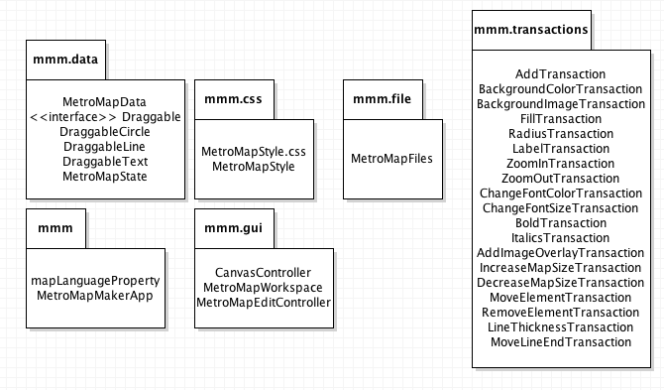The Metro Map Maker will be created using DesktopJavaFramework, JTPS, and PropertiesManager, all of which are frameworks that have been developed already and will not be modified in any way. Figure 2.1 specifies all the components to be developed and places all classes in home packages.

**Figure 2.1: Design Packages Overview**

**2.2 Java API Usage**

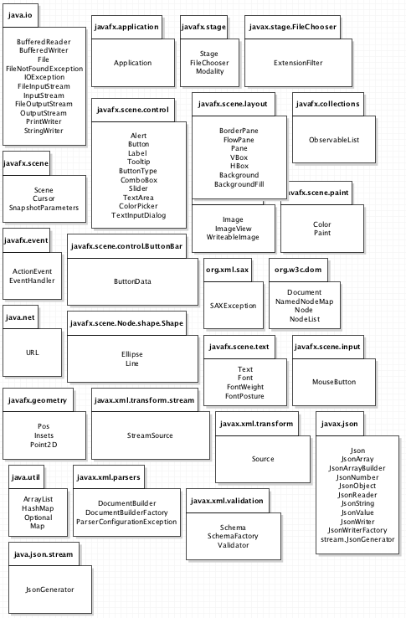Both the frameworks and the Metro Map Maker application will be developed using the Java programming languages. As such, this design will make use of the classes specified in Figure 2.2.

**Figure 2.2: Java API Classes and Packages To Be Used**

**2.3 Java API Usage Descriptions**

Tables 2.1-2.25 below summarize how each of these classes will be used.

|  |  |
| --- | --- |
| **Class/Interface** | **Use** |
| **BufferedReader** | **Used to read data from a JSON file; Used in loading a map** |
| **BufferedWriter** | **Used to write data to a JSON file; Used in saving a map** |
| **File** | **Used to save, load, or create a new map** |
| **FileNotFoundEx-ception** | **Thrown when a file that is trying to be used does not exist or the path is incorrect** |
| **IOException** | **Thrown in response to any general I/O issue.** |
| **FileInputStream** | **Used for loading various data from files** |
| **InputStream** | **A more general version of FileInputStream** |
| **FileOutputStream** | **Used for writing various data to files** |
| **OutputStream** | **A more general version of FileOutputStream** |
| **PrintWriter** | **An aid in writing to files, normally used at the end of saving to a file** |
| **StringWriter** | **Used in tandem with the javax.json library to write to JSON files** |

**Table 2.1: Uses for classes in the Java API’s java.io package**

|  |  |
| --- | --- |
| **Class/Interface** | **Use** |
| **Application** | **Used to create the actual user interface of the program.** |

**Table 2.2: Uses for classes in the Java API’s javafx.application package**

|  |  |
| --- | --- |
| **Class/Interface** | **Use** |
| **Stage** | **Used for the actual GUI of the program** |
| **FileChooser** | **Used for choosing a file to load; Select a file** |
| **Modality** | **Used in Dialog boxes to create the actual popup and have it be in front of the actual application window.** |

**Table 2.3: Uses for classes in the Java API’s javafx.stage package**

|  |  |
| --- | --- |
| **Class/Interface** | **Use** |
| **ExtensionFilter** | **used for filtering which files can be chosen in a FileDialog based on the file name extensions.** |

**Table 2.4: Uses for classes in the Java API’s javafx.stage.FileChooser package**

|  |  |  |
| --- | --- | --- |
| **Class/Interface** | | **Use** |
| **Scene** | **Used as the container for all content in a scene graph.** | |
| **Cursor** | **Used to change the cursor to match what action is being performed. For example, when something is being sized, the cursor will be set as a Crosshair.** | |
| **SnapshotParamet-ers** | **Used in exporting the modified Metro Map.** | |

**Table 2.5: Uses for classes in the Java API’s javafx.scene package**

|  |  |
| --- | --- |
| **Class/Interface** | **Use** |
| **Alert** | **Used generally across the application for various scenarios where input or user action is required. For example, the about button.** |
| **Button** | **Used across the application for various actions in the front-end portion of the application** |
| **Label** | **Used for front-end portion of application; Classify the separate Stations** |
| **Tooltip** | **Used for front-end portion of application; Describes what each button will do** |
| **ComboBox** | **Used for front-end portion of application; Metro Stations/lines, Font** |
| **ButtonType** | **Used for determining input from a Dialog or Alert** |
| **Slider** | **Used for setting values of the Metro Lines and Stations** |
| **TextArea** | **Used to set the value of certain Labels used to represent Stations** |
| **ColorPicker** | **Used to set the color of Metro Lines** |
| **TextInputDialog** | **Used to modify existing Labels that represent Stations** |

**Table 2.6: Uses for classes in the Java API’s javafx.scene.control package**

|  |  |
| --- | --- |
| **Class/Interface** | **Use** |
| **ButtonData** | **Used in the Alert and Dialog APIs to get input from the user based on which Button they select.** |

**Table 2.7: Uses for classes in the Java API’s javafx.scene.ButtonBar package**

|  |  |
| --- | --- |
| **Class/Interface** | **Use** |
| **BorderPane** | **Used for the general structure/look of the entire application** |
| **FlowPane** | **Used for individual toolbars on the top side of the application** |
| **Pane** | **Used for the actual canvas** |
| **VBox** | **Used for individual rows on the left side of the application** |
| **HBox** | **Used for the left side of the application** |
| **Background** | **Used to reference the background of the application to modify its properties** |
| **BackgroundFill** | **Used to set the color of the Background** |

**Table 2.8: Uses for classes in the Java API’s java.scene.layout package**

|  |  |
| --- | --- |
| **Class/Interface** | **Use** |
| **Color** | **Used for setting the various colors of Circles or lines throughout the Map.** |
| **Paint** | **Used for setting the fill of Circles representing individual stations** |

**Table 2.9: Uses for classes in the Java API’s javafx.scene.paint package**

|  |  |
| --- | --- |
| **Class/Interface** | **Use** |
| **Image** | **Used for adding an Image to the canvas by using ImageView** |
| **ImageView** | **The actual object that will be added to the canvas using an image in its constructor.** |
| **WritableImage** | **Used for creating a snapshot of the canvas and saving it as an image.** |

**Table 2.10: Uses for classes in the Java API’s javafx.scene.image package**

|  |  |
| --- | --- |
| **Class/Interface** | **Use** |
| **MouseButton** | **Used to differentiate between different types of clicks (e.g. right click vs. left click).** |

**Table 2.11: Uses for classes in the Java API’s javafx.scene.input package**

|  |  |
| --- | --- |
| **Class/Interface** | **Use** |
| **Text** | **Used across the application to display Text that is used for the actual Metro Stations.** |
| **Font** | **Used for general font needs, like changing the font type, size, weight,**  **posture, etc.** |
| **FontWeight** | **Used to set whether or not a Font is bolded** |
| **FontPosture** | **Used to set whether or not a Font is italicized** |

**Table 2.12: Uses for classes in the Java API’s javafx.scene.text package**

|  |  |
| --- | --- |
| **Class/Interface** | **Use** |
| **ActionEvent** | **Used for setting the various colors of Circles or lines throughout the Map.** |
| **EventHandler** | **Used in the backend portion of the application; Used to perform any action depending on what was selected or activated.** |

**Table 2.13: Uses for classes in the Java API’s javafx.event package**

|  |  |
| --- | --- |
| **Class/Interface** | **Use** |
| **URL** | **Used to refer to any file or directory in the system. For example, adding an image would make use of URL.** |

**Table 2.14: Uses for classes in the Java API’s java.net package**

|  |  |
| --- | --- |
| **Class/Interface** | **Use** |
| **Pos** | **Used for setting the alignment of various nodes throughout the application** |
| **Insets** | **Used to set the spacing between multiple nodes throughout the application.** |

**Table 2.15: Uses for classes in the Java API’s javafx.geometry package**

|  |  |
| --- | --- |
| **Class/Interface** | **Use** |
| **ArrayList** | **Used primarily for implementing a stack for the undo/redo portion of the application** |
| **HashMap** | **Used primarily to keep track of the various properties of the nodes throughout the application** |
| **Optional** | **Used to save the input from an Alert or Dialog message.** |

**Table 2.16: Uses for classes in the Java API’s java.util package**

|  |  |
| --- | --- |
| **Class/Interface** | **Use** |
| **Circle** | **Used for physically representing the Metro stations.** |
| **Lines** | **Used to connect the various Metro stations throughout the Map.** |

**Table 2.17: Uses for classes in the Java API’s javafx.scene.Node.shape.Shape package**

|  |  |
| --- | --- |
| **Class/Interface** | **Use** |
| **Source** | **Used to locate and read an XML File using a StreamSource object.** |

**Table 2.18: Uses for classes in the Java API’s javax.xml.transform package**

|  |  |
| --- | --- |
| **Class/Interface** | **Use** |
| **StreamSource** | **Used to locate an XML File that would be used by a Source object.** |

**Table 2.19: Uses for classes in the Java API’s javax.xml.transform.stream package**

|  |  |
| --- | --- |
| **Class/Interface** | **Use** |
| **Schema** | **Used for checking/enforcing against an XML document** |
| **SchemaFactory** | **Used to read external representations of schemas and prepare them for validation.** |
| **Validator** | **Used for checks an XML document against**[**Schema**](https://docs.oracle.com/javase/7/docs/api/javax/xml/validation/Schema.html)**.** |

**Table 2.20: Uses for classes in the Java API’s java.xml.validation package**

|  |  |
| --- | --- |
| **Class/Interface** | **Use** |
| **DocumentBuilder** | **Used for parsing an XML file from a variety of input sources** |
| **DocumentBuilder-Factory** | **enables applications to obtain a parser that produces DOM object trees from XML documents** |
| **ParserConfigurat-ionException** | **Thrown when there is a major issue parsing an XML File.** |

**Table 2.21: Uses for classes in the Java API’s java.xml.parsers package**

|  |  |
| --- | --- |
| **Class/Interface** | **Use** |
| **SAXException** | **Used contain basic error or warning information from either the XML parser or the application:** |

**Table 2.22: Uses for classes in the Java API’s org.xml.sax package**

|  |  |
| --- | --- |
| **Class/Interface** | **Use** |
| **Document** | **Represents the entire HTML or XML document** |
| **NamedNodeMap** | **used to represent collections of nodes that can be accessed by name** |
| **Node** | **the primary datatype for the entire Document Object Model; Will represent Stations and Lines that will be added to the canvas.** |
| **NodeList** | **provides the abstraction of an ordered collection of nodes, without defining or constraining how this collection is implemented.** |

**Table 2.23: Uses for classes in the Java API’s org.w3c.dom package**

|  |  |
| --- | --- |
| **Class/Interface** | **Use** |
| **Json** | **The builder class upon which all of the javax.json objects can be built** |
| **JsonArray** | **An array specifically tailored to hold various Json objects** |
| **JsonArrayBuilder** | **An object that uses the builder design pattern to create a JsonArray.** |
| **JsonNumber** | **A number class that stores values in a number-based format, provided that the data, in some other form, contains numbers and nothing else.** |
| **JsonObject** | **A general object whose backing structure is a Map-based structure (Key/Value pairs), and is essential for saving to JSON files** |
| **JsonReader** | **An object used in tandem with InputStreams to load JSON files** |
| **JsonValue** | **An interface that contains enumerable types for JsonString, JsonObject, JsonNumber, JsonTrue, JsonFalse, and JsonArray** |
| **JsonWriter** | **An object that works in tandem with various Writer objects (like the PrintWriter) to write to a JsonObject** |
| **JsonWriterFactory** | **The creator of the JsonWriter through the use of the factory desgin pattern** |
| **JsonString** | **A Json container for String variables** |
| **JsonObjectBuilder** | **The creater of the JsonObject through the use of the builder design pattern.** |

**Table 2.24: javax.json API usage**

|  |  |
| --- | --- |
| **Class/Interface** | **Use** |
| **JsonGenerator** | **For writing JSON data to some output source, like a JSON file**  **or a JsonObject** |

**Table 2.25: Uses for classes in the Java API’s java.json.streampackage**

**Part 3: Class-Level Design Viewpoint**

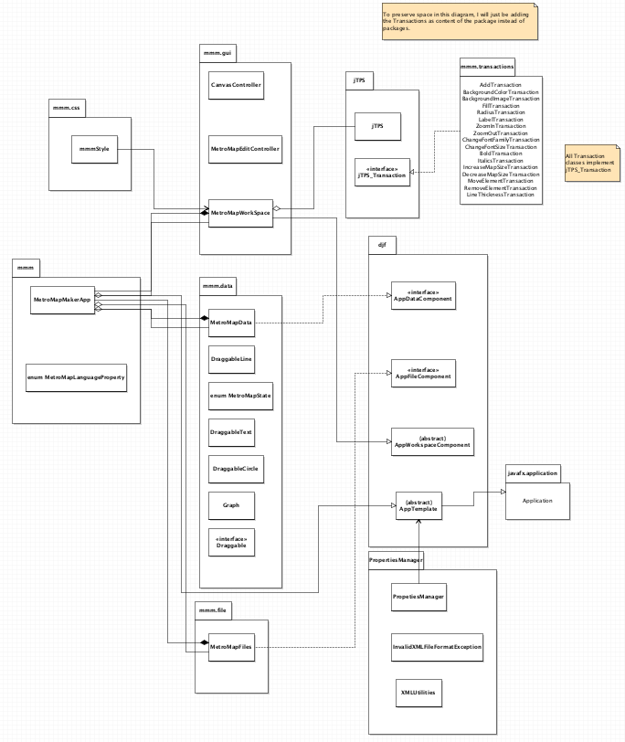As mentioned before, this design will encompass both the Metro Map Maker application, the jTPS Framework, Desktop Java Framework, and Properties Manager. The following UML Class diagrams will reflect this. The following diagrams are sorted in level of detail. The three frameworks that have been provided will not have their own UML diagrams, but they will be references in the overall design.

**Figure 3.1: Metro Map Maker Overview UML Class Diagram**

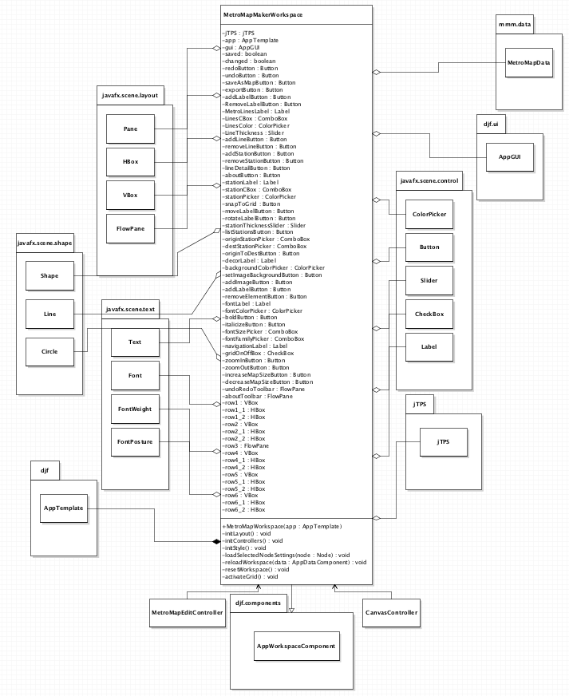

**Figure 3.2: MetroMapWorkspace class UML Diagram**

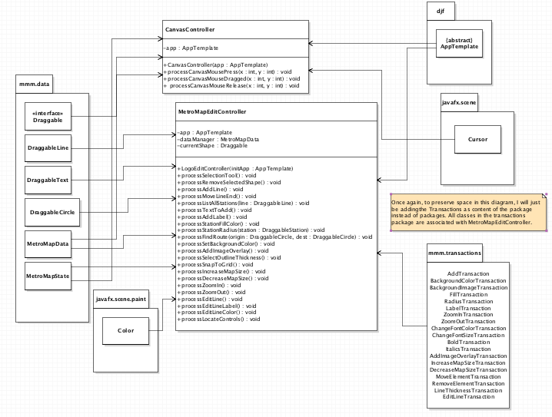

**Figure 3.3: MetroMapEditController and CanvasController classes UML Diagram**

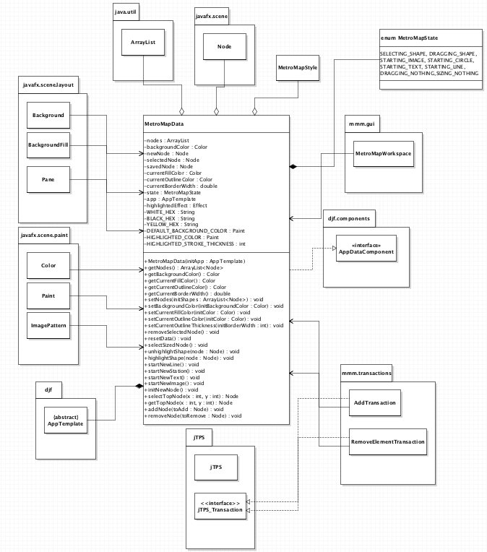

**Figure 3.4: MetroMapData Class UML Diagram**

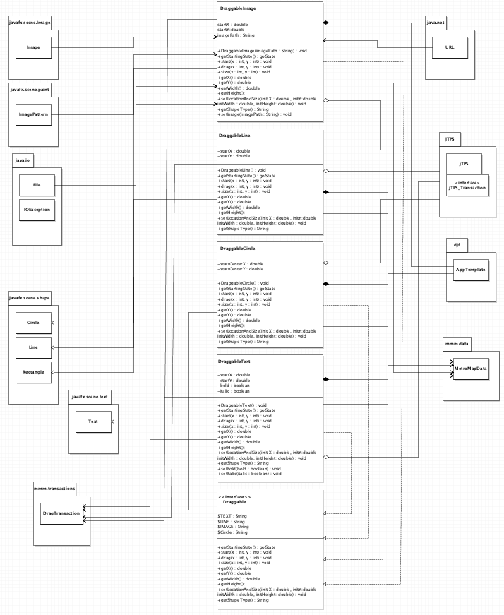

**Figure 3.5: Draggable Interface + Objects Classes UML Diagram**

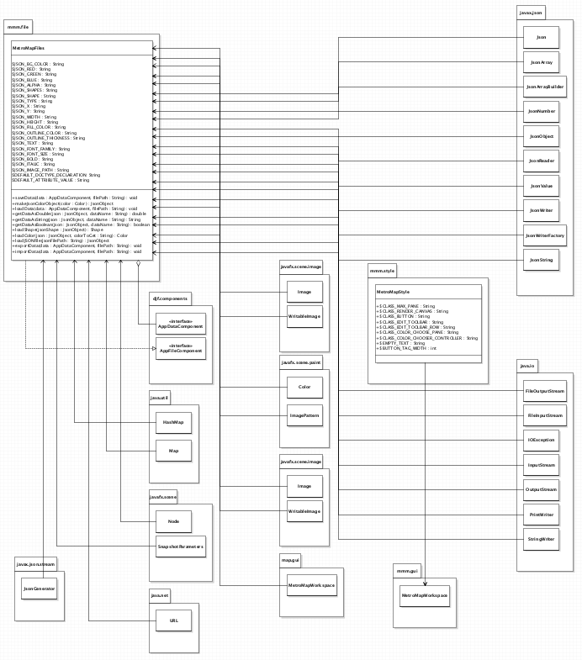

**Figure 3.6: MetroMapFiles and MetroMapStyle Classes UML Diagram**

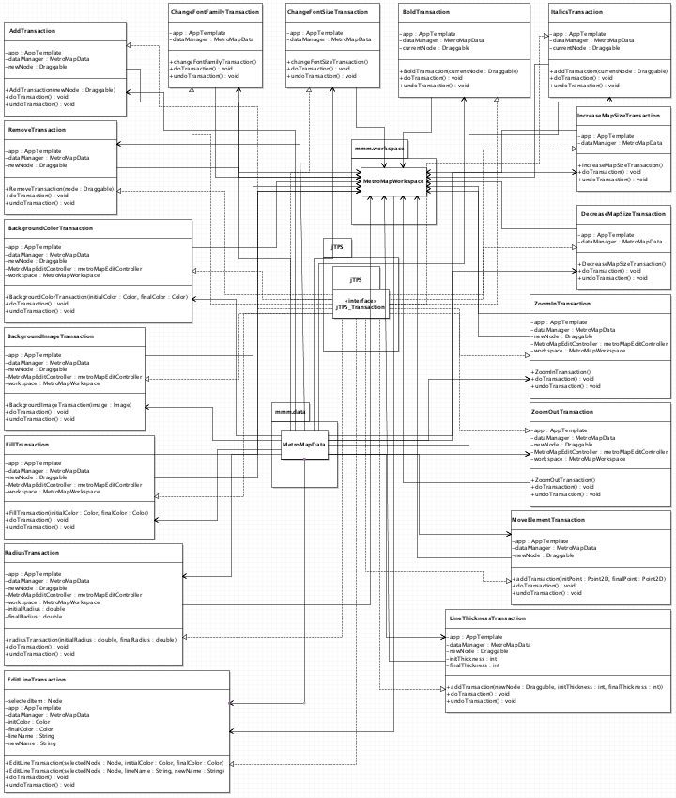

**Figure 3.7: Transaction Classes UML Diagram (Part ½)**

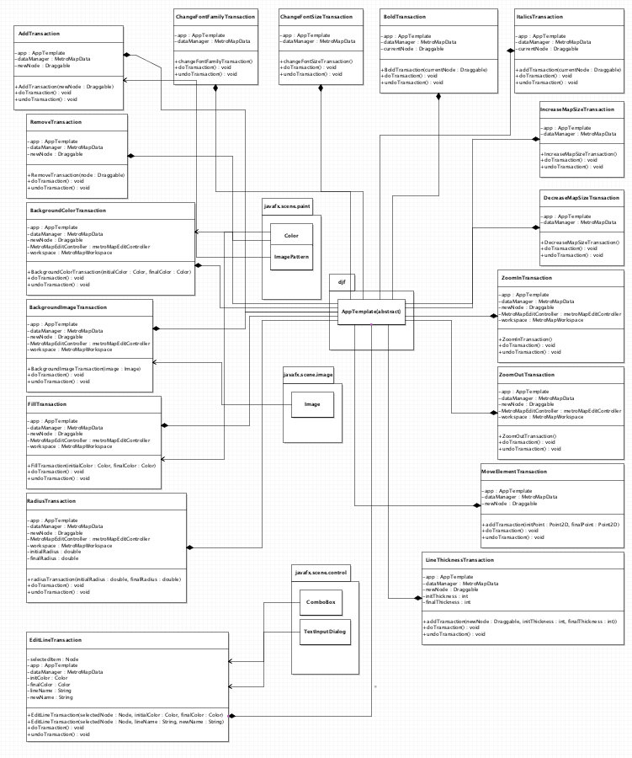

**Figure 3.8: Transaction Classes UML Diagram (Part 2/2)**

**Part 4: Method-Level Design Viewpoint**

After discussing the class architecture, it is crucial to understand how the methods in each class are intertwined and how they depend on one another. The following UML Sequence Diagrams describe the relationships between methods called within the code to provide appropriate event responses.



**Figure 4.1: Use case 2.15 -> Move Line End**



**Figure 4.2: Use case 2.17 -> Remove Stations from Line**

**Figure 4.3: Use case 2.39 -> Exit Application**



**Figure 4.4: Use case 2.3 -> Exit Welcome Dialog**

**Figure 4.5: Use case 2.23 -> Move Station Label**

**Figure 4.6: Use case 2.27 -> Find Route**



**Figure 4.7: Use case 2.34 -> Change Font Color**



**Figure 4.8: Use case 2.28 -> Change Font Color**



**Figure 4.9: Use Case 2.14 -> Edit Line**



**Figure 4.10: Use Case 2.1 -> Create New Map**



**Figure 4.11: Use Case 2.36 -> Zoom In**



**Figure 4.12: Use Case 2.11 -> Learn About Application**



**Figure 4.13: Use Case 2.9 -> Undo Edit**



**Figure 4.14: Use Case 2.16 -> Add Stations to Line**

**Figure 4.15: Use Case 2.13**

**Part 5: File Structure and Formats**

The Desktop Java Framework will be used in the Metro Map Maker application and it will be compiled using a .jar file. This should be imported into the necessary project for the Metro Map Maker application and will be included in the deployment of a single, executable JAR file titled MetroMapMaker.jar. Note that all necessary data and art files must accompany this program. Figure 5.1, shown below, demonstrates the folder layout of the main Metro Map application

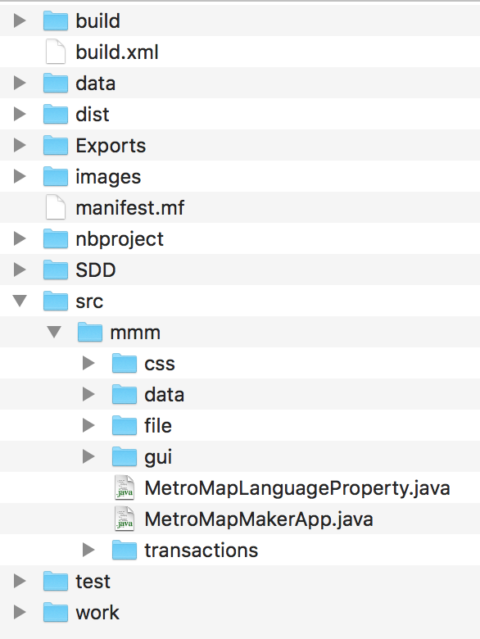

**Figure 5.1: Metro Map Maker File Structure**

The file formats that will be used in this application are XML, JSON, and CSS.

* XML:. XML files will be used to store properties for the application, allowing for easy saving and loading of the application.
* JSON: **J**ava**S**cript **O**bject **N**otation. This is a file format to which everything will be saved when working and saving inside this application.
* CSS: Cascading Style Sheets: This file type uses the CSS language to add style to a given application in the form of colors, spacing between nodes, font styles, and other aesthetic designs.

**Part 6: Supporting Information**

Note that this document should serve as a reference for those implementing the code, so we’ll provide a table of contents to help quickly find important sections. Also note that due to the information needed in some of the UML diagrams, one might need to zoom in on the document if being viewed electronically. I apologize in advance for the inconveniences.

**Table of Contents**

1. Introduction 2  
 1. Purpose 2  
 2. Scope 2  
 3. Definitions, Acronyms, and Abbreviations 2  
 4. References 3  
 5. Overview 3  
2. Package-Level Design Viewpoint 4  
 1. MetroMapMaker overview 4  
 2. Java API Usage 5  
 3.Java API Usage Descriptions 6  
3. Class-Level Design Viewpoint 14

4. Method-Level Design Viewpoint 22

5. File Structure and Formats 30

6. Supporting Information 31